Lakmali Amarawardana

This report analyses NHS appointment data across multiple datasets, focusing on workforce structure, regional variation, service delivery patterns and system performance. It aims to identify demand trends and assess the efficiency of NHS healthcare services.

Investigating Appointment Trends, Regional Variation and Service Efficiency in NHS care

NHS datasets: Overview
The Actual duration (ad) dataset contains information on appointment lengths and location details across 106 sub-ICB locations. It has over 137,000 records with a right-skewed distribution of appointment counts. A significant proportion of entries marked as “Unknown” or with data quality issues, particularly in 2021 (20.66%), indicating gaps in recording accuracy.
The Regional appointments (ar)dataset focuses on patient interactions, including attendance, healthcare professional type, and waiting time from booking to appointment. This dataset is useful for analysing service efficiency and patient behaviour. It also contains 21,604 duplicate records, highlighting ongoing data recording inconsistencies, though less severe than in the ad dataset.
The National categories(nc) dataset provides a structured overview of NHS activity across 106 sub-ICB locations, using five service settings, 18 national categories, and three context types. Unlike the other datasets, it contains no duplicates, making it more reliable for comparison and high-level analysis.
Overall, data quality is inconsistent across the datasets. The ‘ad’ and ‘ar’ datasets show clear duplication and completeness issues, while the National dataset appears more robust. This means data cleaning and validation are essential before analysis to ensure reliable results.
However, the datasets were analysed with duplicates left intact as they likely reflect underlying data recording and reporting practices rather than purely erroneous entries. Retaining these duplicates ensures that the analysis preserves the true volume and distribution of recorded activity, even though it may introduce some bias.

Background and context of the business
Investigate focus on variations in appointment volumes across regions and time in order to identify demand trends, optimise resource allocation and improve service efficiency in healthcare delivery.

Objectives
- Identifiable seasonal trends.
- Analyse regional differences in healthcare service usage
- Use of appointment data to improve healthcare service planning and reduce system strain.

Findings
Workforce Structure
- GP and Other Practice Staff account for the majority of appointments across datasets.
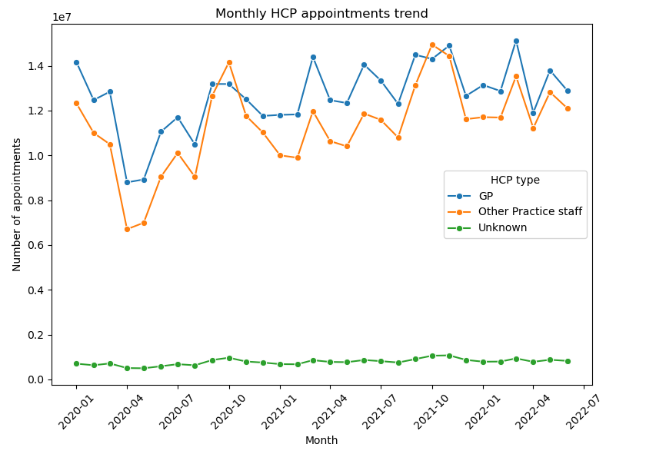
- GPs contribute slightly more (~51%), while Other Practice Staff account for ~46%.
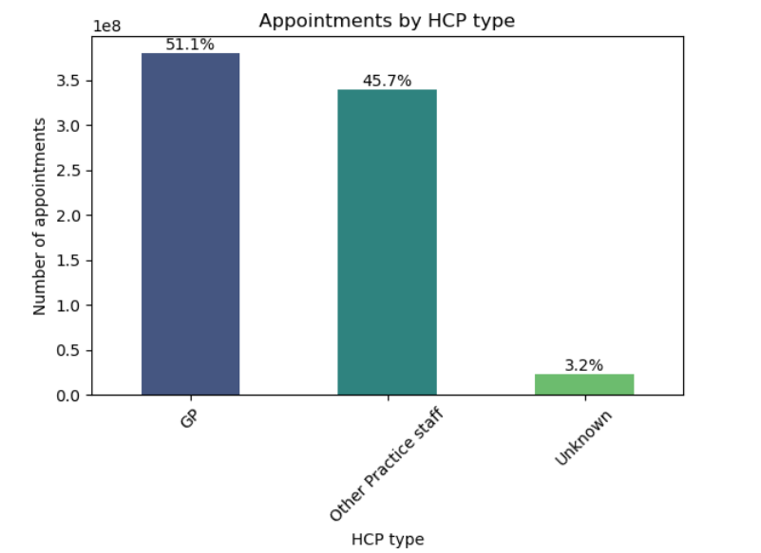

Growth and Demand Pressure
- Regional data shows a strong upward trend in appointments over time (~203,000 increase per month).
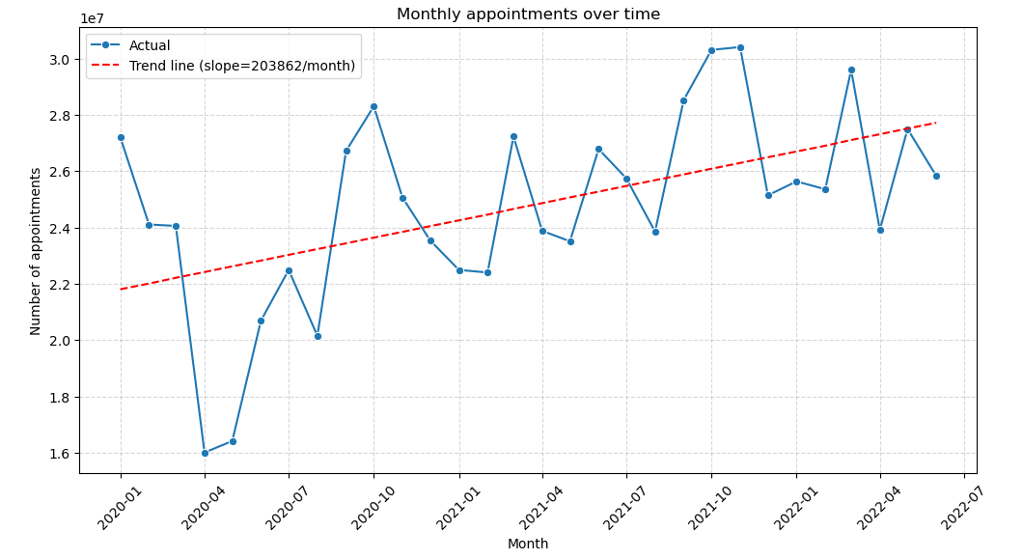
- GP and Other Practice Staff appointments both show gradual monthly increases (~10–14 appointments/month).
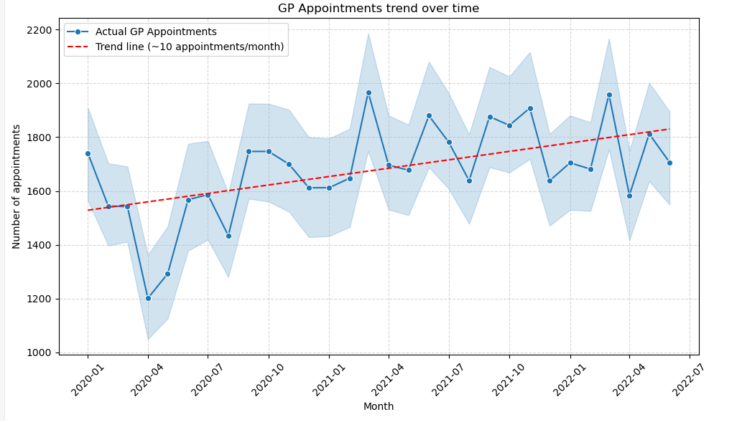

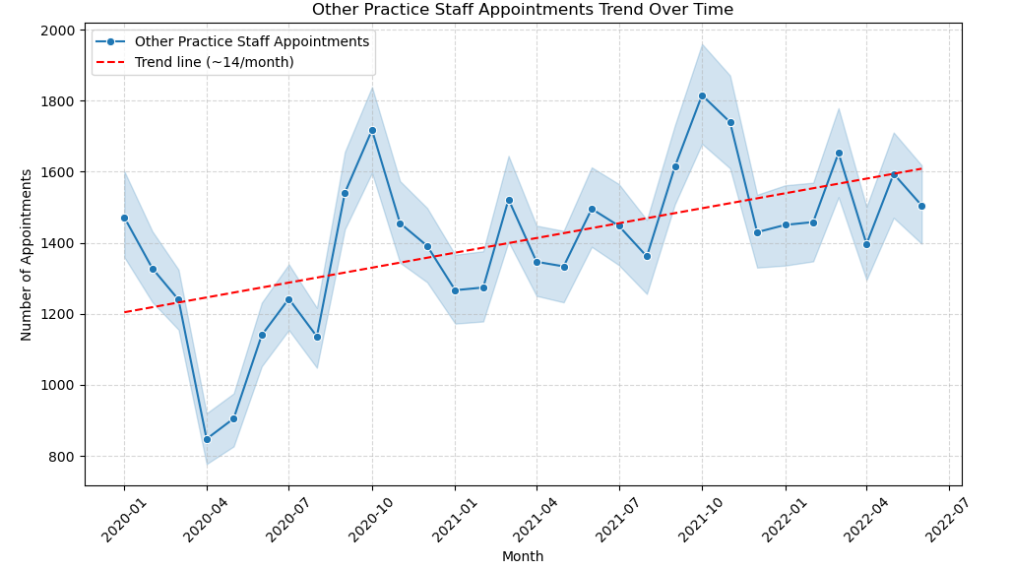
- Appointment volumes vary across ICBs, some handling over 6 million appointments, while others handle far fewer.
Appointments by Sub-ICB Location
Rank | Sub ICB Location | Count of Appointments | % Share
1 | NHS North West London ICB - W2U3Z | 6,976,986 | 11.18%
2 | NHS North East London ICB - A3A8R | 5,341,883 | 8.56%
3 | NHS Kent and Medway ICB - 91Q | 5,209,641 | 8.35%
4 | NHS Hampshire and Isle of Wight ICB - D9Y0V | 4,712,737 | 7.55%
5 | NHS South East London ICB - 72Q | 4,360,079 | 6.98%
… | … | … | …
102 | NHS Cheshire and Merseyside ICB - 01V | 358,060 | 0.57%
103 | NHS Cheshire and Merseyside ICB - 01F | 348,396 | 0.56%
104 | NHS Cheshire and Merseyside ICB - 01T | 340,895 | 0.55%
105 | NHS Lancashire and South Cumbria ICB - 02G | 311,713 | 0.50%

- National dataset shows a month-on-month decline of appointments; this could lead to a potential annual reduction of ~1.6 million appointments (reduction of appointments per month: -134603).

Service Delivery Patterns
- Most appointments are short (under 15 minutes) in the Actual Duration dataset.
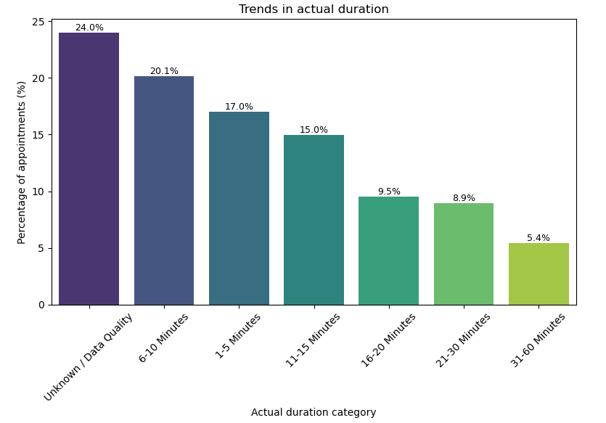
- Face-to-face appointments dominate (~59%), followed by telephone (~36%).
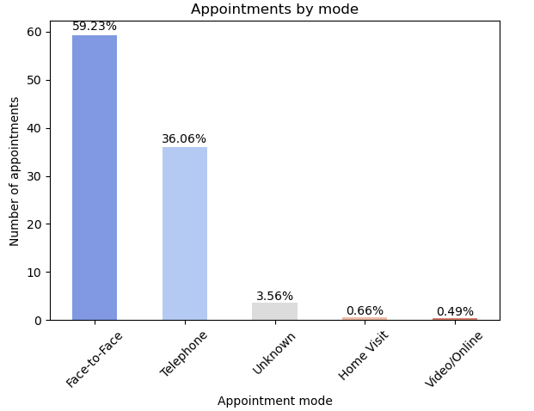
- Video/online and home visits remain minimal across regions.
- General Practice is the main service setting in the national dataset.
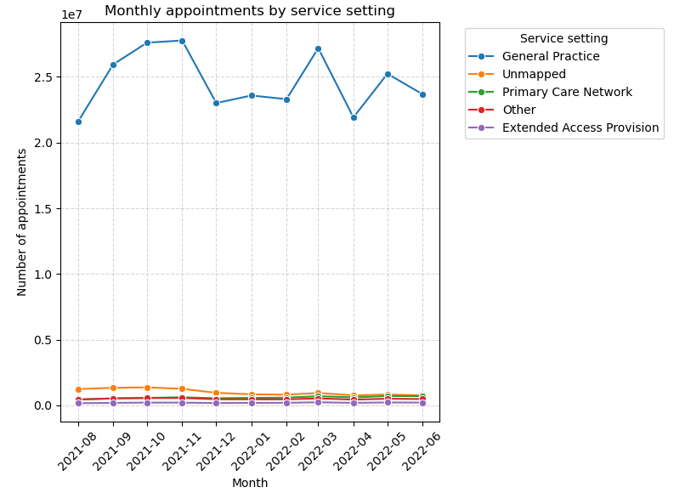
- General Consultation Routine is the most common activity (8–10 million monthly).
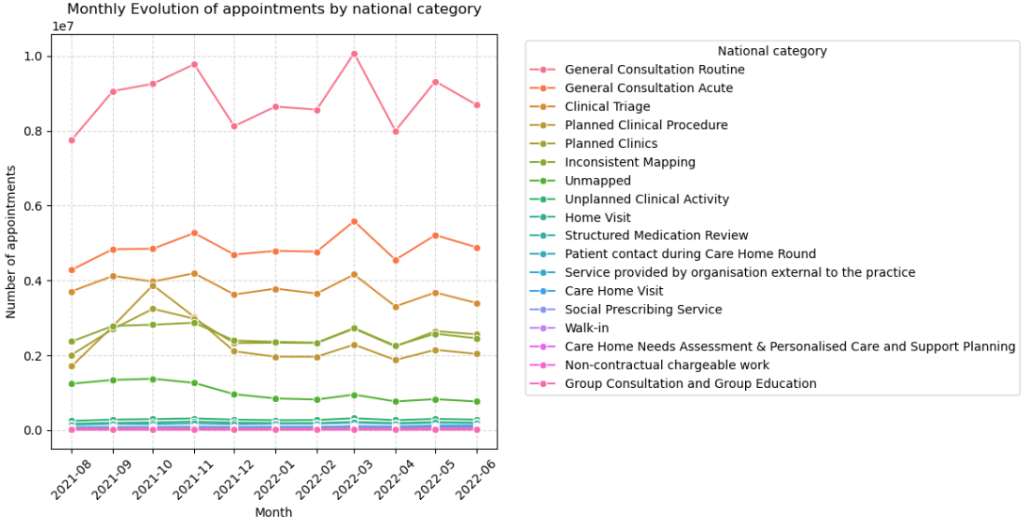

System Performance
- Most appointments occur within same day to 7 days, with high attendance rates.
- Attended appointments dominate across all time bands.
- DNA (Did Not Attend) rates are very low overall.
- Financial impact: ~£50.4 million lost due to missed appointments.
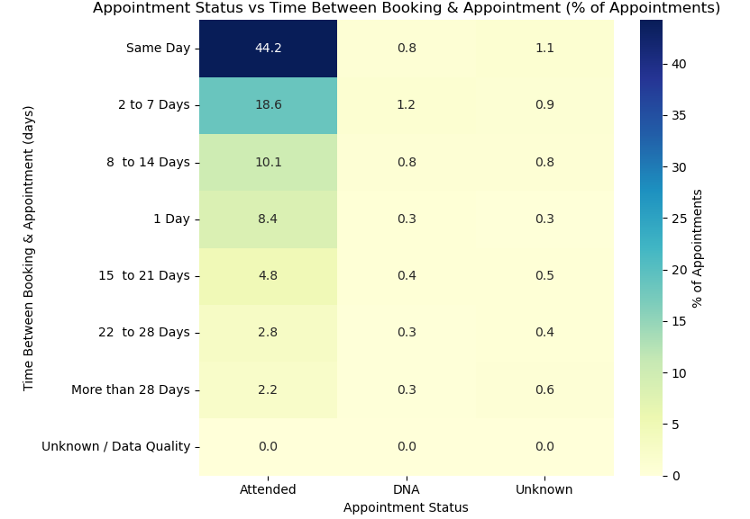
- DNA rates are very low and capacity utilisation averages around ~91%.
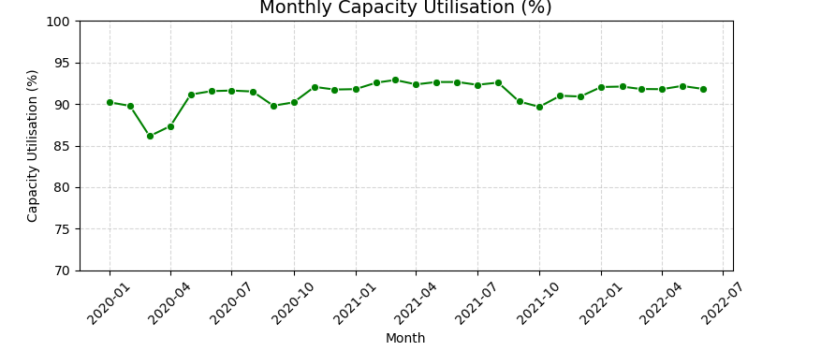
- A significant portion of data includes Unknown or data quality issues (e.g., duration categories, mapping issues).
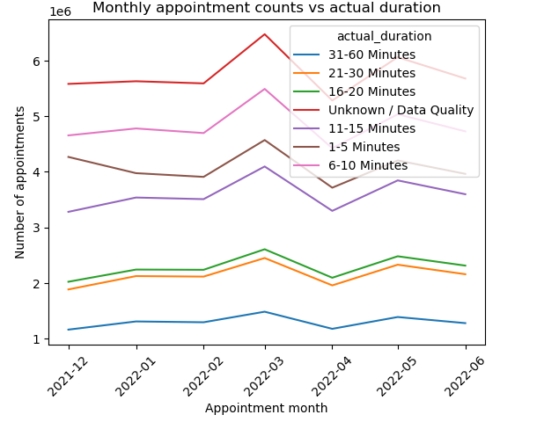
- Duplicate records are present in Actual Duration and Regional datasets but not in the National dataset.

Social Media Communication Performance
- Health-related hashtags dominate the conversation, with #healthcare used far more than others. Key themes include healthcare, technology/AI, jobs and COVID.
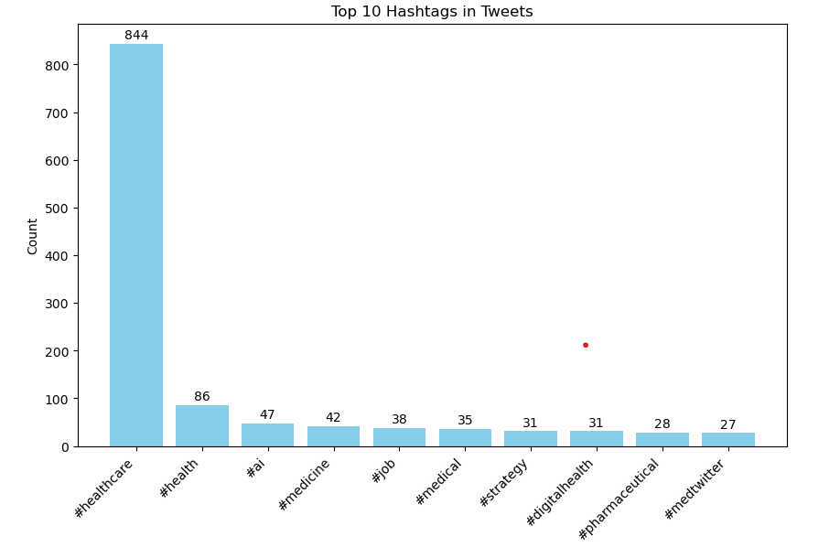
- Most tweets receive very few retweets, while only a small number get very high engagement. The most retweeted posts are often not directly related to healthcare or medical discussions.
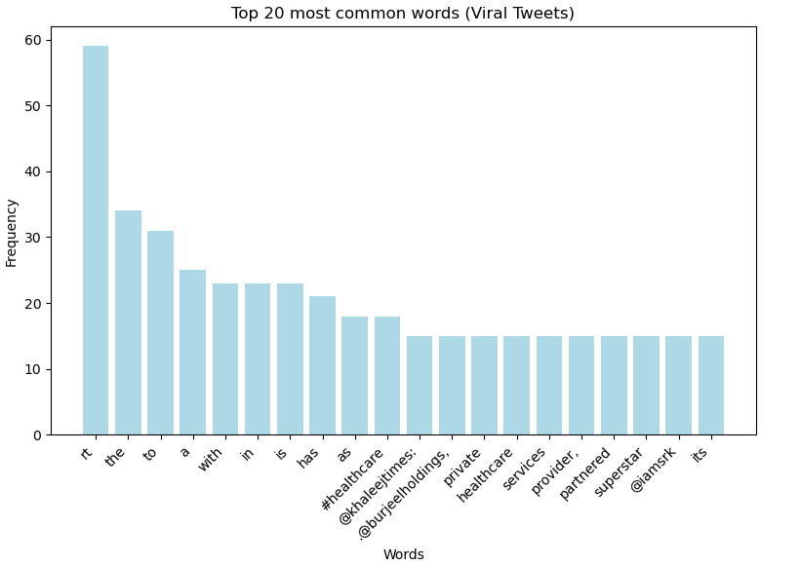
- Tweets mainly focused on healthcare, with “healthcare” and “health” as the most frequent words. However, many posts are related to jobs and recruitment, some AI, COVID, and medical terms, showing a mix of healthcare discussion and employment-related content.
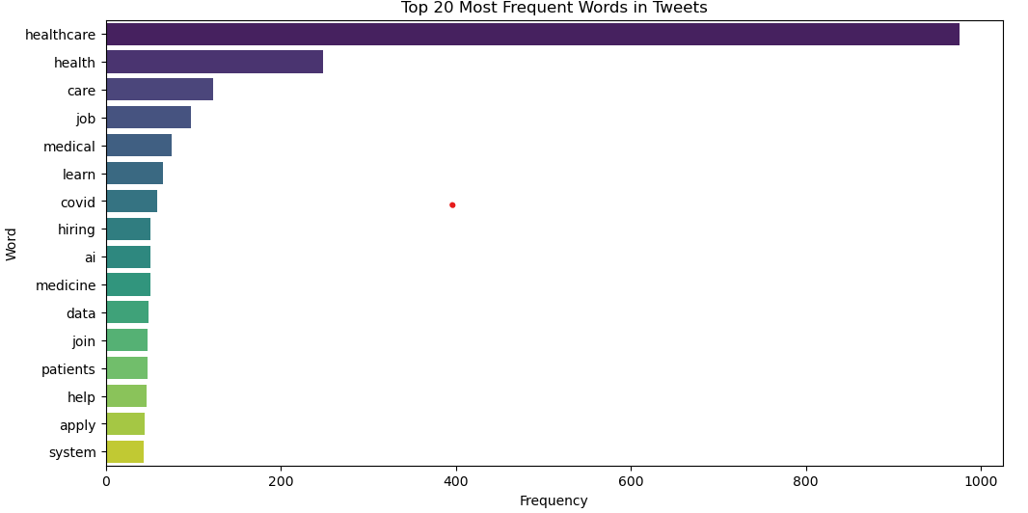
- Sentiment is largely favourable with limited negative discussion.

Sentiment Category | Count
Positive | 618
Neutral | 449
Negative | 107

Insights
- NHS demand is increasing over time, with evidence of uneven pressure across regions.
- NHS services are designed around high-volume, short-duration consultations, supporting efficiency and rapid patient turnover.
- Service delivery remains largely traditional (face-to-face and telephone) with minimal adoption of digital consultations.
- Routine care dominates activity, indicating a strong focus on day-to-day patient management rather than specialised services.
- The NHS operates a shared workforce model, with GPs leading care but increasingly supported by Other Practice Staff.
- The system is running at high utilisation levels, with strong same-day access indicating good responsiveness but potential capacity strain.
- Although the most appointments are attended; the missed appointments
creates substantial financial waste (~£50M).
- Data quality limitations remain, including duplicates, “Unknown” categories, and inconsistent mapping, which may affect accuracy of insights.
- Differences across datasets may reflect data recording practices, service restructuring or external system factors.
- Tweets are mainly focus on healthcare, jobs, AI and medical related. Engagement is highly uneven, most tweets receiving little attention and a few gaining high visibility. Sentiment is mostly positive or neutral with very few negative posts.

Conclusion
NHS appointment data shows a high-demand, high-utilisation system with increasing pressure over time, supported by a shared workforce model, dominated by short, routine, face-to-face care. Dataset is affected by some data quality limitations that impact the accuracy of analysis.
Recommendations
- Improve workforce planning across regions to address uneven appointment volumes and reduce pressure on high-demand ICBs by better distributing GP and Other Practice Staff capacity.
- Strengthen data quality and standardisation, particularly by reducing “Unknown”, “Unmapped”, and duplicate records to improve reliability of reporting and decision-making.
- Support demand management strategies, such as improving triage systems and expanding use of Clinical Triage and Planned Clinics to reduce pressure on routine GP consultations.
- Address financial inefficiency linked to missed appointments (~£50M estimated impact) by improving attendance management through reminders, triage optimisation and better scheduling practices.
- Increase use of non-GP workforce, further utilising Other Practice Staff to manage routine and low-complexity appointments and improve system efficiency.
- Expand digital consultation adoption, as video/online appointments remain extremely low despite policy support, suggesting an opportunity to reduce in-person demand.
- Improve capacity management in high-demand regions, especially ICBs with significantly higher appointment volumes, to reduce risk of system strain.
- Enhance service accessibility and appointment flow, ensuring demand is managed more evenly across time and reducing reliance on same-day appointments where possible.
- Improve social media engagement by making tweets more shareable; use clearer messaging, visuals and real patient or staff stories rather than mainly job postings or generic updates.
END.

